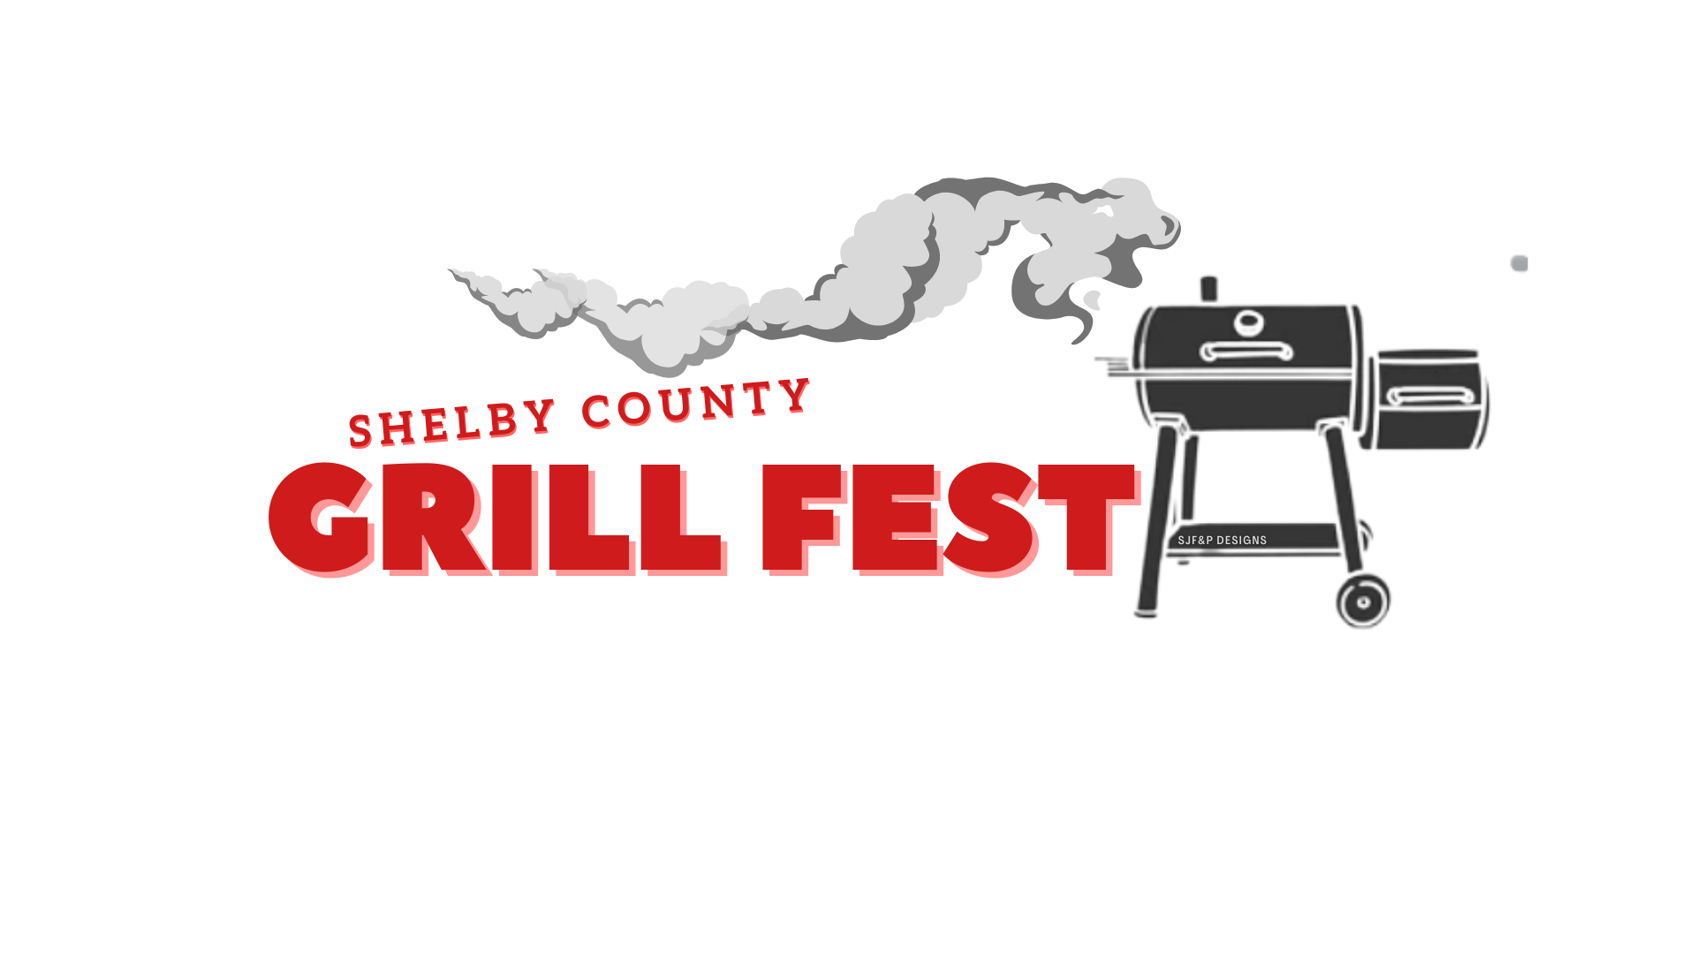

Sponsored by
Farmers State Bank
April 24 & 25, 2026

Friday, April 24th

*42 Tournament (Sponsored by Shelby Savings Bank)
5:30pm Registration $10 per person/$20 per team
6:00pm Tournament begins

*Washer Pitching Tournament (Sponsored by Shelby Savings Bank)
7:00pm - $10 per person/$20 per team

*Margarita Competition 7:00pm $10 per entry

*“Open” Competition 7:30pm $10 per entry

Karaoke – 8:00-10:00pm (Sponsored by Brock’s Rocks)

Saturday, April 25th

*Bloody Mary Competition 10am $10 per entry

*Beans Competition 11am $10 per entry

*12noon Chicken Competition

*1:30pm Ribs Competition

*3:00pm Brisket Competition

Awards

